

**Tribhuvan University**

**Faculty of Humanities and Social Sciences**

**TITLE OF PROJECT REPORT**

ConnectMe: A Niche Social Media Platform

**A PROJECT REPORT**

**Submitted to**

**Department of Computer Application**

**Ambikeshwari College**

***In partial fulfillment of the requirements for the Bachelors in Computer Application***

Submitted by

Name: Manish Bhusal

Roll No:- 13

Date of Submission: 2024-09-03

Under the Supervision of

**Nabraj Basel**



**Tribhuvan University**

**Faculty of Humanities and Social Sciences**

**Ambikeshwari College**

**Supervisor’s Recommendation**

I hereby recommend that this project prepared under my supervision by Manish Bhusal entitled “**ConnectMe: A Niche Social Media Platform”** in partial fulfillment of the requirements for the degree of Bachelor of Computer Application is recommended for the final evaluation.

Signature of the Supervisor

**SIGNATURE**

# SUPERVISOR

BCA

Ghorahi-15, Dang



**Tribhuvan University**

**Faculty of Humanities and Social Sciences**

**Ambikeshwari College**

**LETTER OF APPROVAL**

This is to certify that this project prepared by Manish Bhusal entitled “**ConnectMe: A Niche Social Media Platform”** in partial fulfillment of the requirements for the degree of Bachelor in Computer Application has been evaluated. In our opinion it is satisfactory in the scope and quality as a project for the required degree.

|  |  |
| --- | --- |
| **SIGNATURE of Supervisor** | **SIGNATURE of HOD/ Coordinator** |
| **SIGNATURE of Internal Examiner** | **SIGNATURE of External Examiner** |

Ambikeshwari College

Ref No:

Date:

## Subject: Approval of Project Proposal

The project entitled “ConnectMe: A Niche Social Media Platform” proposed by Mr. Manish Bhusal for the partial fulfillment of the requirement for Bachelor in Computer Application (BCA), fourth semester has been approved for further development.

**Proposal Evaluation Committee**

1. **_______________________**
2. **_______________________**
3. **_______________________**
4. **_______________________**

Mr. Chandra Prakash Khanal

Campus Chief

Contents

Chapter 1 Introduction 6

1.1 Introduction of Proposed project 6

The project, titled "ConnectMe: A Niche Social Media Platform," aims to create an innovative social media platform focused on connecting users with shared interests through specialized communities. In the first phase of development, the platform will implement essential CRUD operations and user authentication features. This phase will establish a foundation for future enhancements, making ConnectMe a dynamic and engaging platform for users to explore and interact within their chosen communities. 6

1.2 Problem Statement 6

1.3 Objectives 6

1.4 Scope and limitation 7

Chapter 2 Literature Review 7

Chapter 3 Methodology 7

3.1 System Analysis 7

Chapter 4 Conclusion 9

4.1 Expected Outcome 10

References 10

# Chapter 1 Introduction

## 1.1 Introduction of Proposed project

## The project, titled "ConnectMe: A Niche Social Media Platform," aims to create an innovative social media platform focused on connecting users with shared interests through specialized communities. In the first phase of development, the platform will implement essential CRUD operations and user authentication features. This phase will establish a foundation for future enhancements, making ConnectMe a dynamic and engaging platform for users to explore and interact within their chosen communities.

## 1.2 Problem Statement

Traditional social media platforms often focus on broad, generalized interactions, making it difficult for users to connect meaningfully with others who share specific interests. This results in cluttered feeds and irrelevant content, leading to reduced user engagement and satisfaction. There is a need for a platform that allows users to connect within niche communities, fostering more relevant and personalized interactions.

## 1.3 Objectives

a. Develop a secure user authentication system with support for email-based signup and OAuth integration.

b. Implement CRUD operations for user profiles, communities, posts, and comments.

c. Enable users to create, join, and manage communities based on shared interests.

Provide a basic user dashboard with activity feeds and simple analytics to track engagement.

## 1.4 Scope and limitation

**Scope**

1. The first phase focuses on core functionalities like user authentication, community management, and basic CRUD operations.
2. A responsive design will be implemented to ensure accessibility across devices.

**Limitation**

1. Advanced features like AI-driven recommendations and direct messaging will be developed in subsequent phases.
2. The initial deployment will handle a limited number of users and communities, with scalability planned for later stages.

# Chapter 2 Literature Review

The project builds on existing research and platforms that emphasize the importance of niche social networks. Studies show that users are more likely to engage in platforms that cater to their specific interests. This section will explore the successes and shortcomings of current social media platforms, identifying opportunities for improvement that ConnectMe aims to address.

# Chapter 3 Methodology

## 3.1 System Analysis

It is a process of collecting and interpreting facts, identifying the problems, and decomposition of a system into its components.

System analysis is conducted for the purpose of studying a system or its parts in order to identify its objectives. It is a problem solving technique that improves the system and ensures that all the components of the system work efficiently to accomplish their purpose. [2]

The system will be analyzed based on user needs, focusing on creating a platform that is intuitive, secure, and easily scalable. The analysis will include:

* 1. **User Requirements:** Understanding the needs of users seeking niche communities.
  2. **Functional Requirements**: Defining CRUD operations, user authentication, and community management.
  3. **Non-Functional Requirements**: Ensuring the platform is secure, responsive, and user-friendly.

**3.2 System Design**

The system design will involve:

* **Frontend**: Developed using React, with components for authentication, community management, and user interaction.
* **Backend**: Built with ASP.NET Core, handling API requests, database interactions, and business logic.
* **Database**: Implemented using SQL Server or PostgreSQL, managed through Entity Framework, supporting CRUD operations.

**3.3 Project Schedule**

The project will be developed in iterative cycles, with milestones for:

* **Week 1-2**: Requirement gathering and system analysis.
* **Week 3-4**: Frontend and backend setup, including database schema design.
* **Week 5-6**: Development of user authentication and profile management features.
* **Week 7-8**: Implementation of community creation and management, post creation, and CRUD operations.
* **Week 9-10**: Integration of the dashboard and analytics features, followed by testing and debugging.
* **Week 11-12**: Final testing, deployment, and documentation.

**Gantt Chart:**

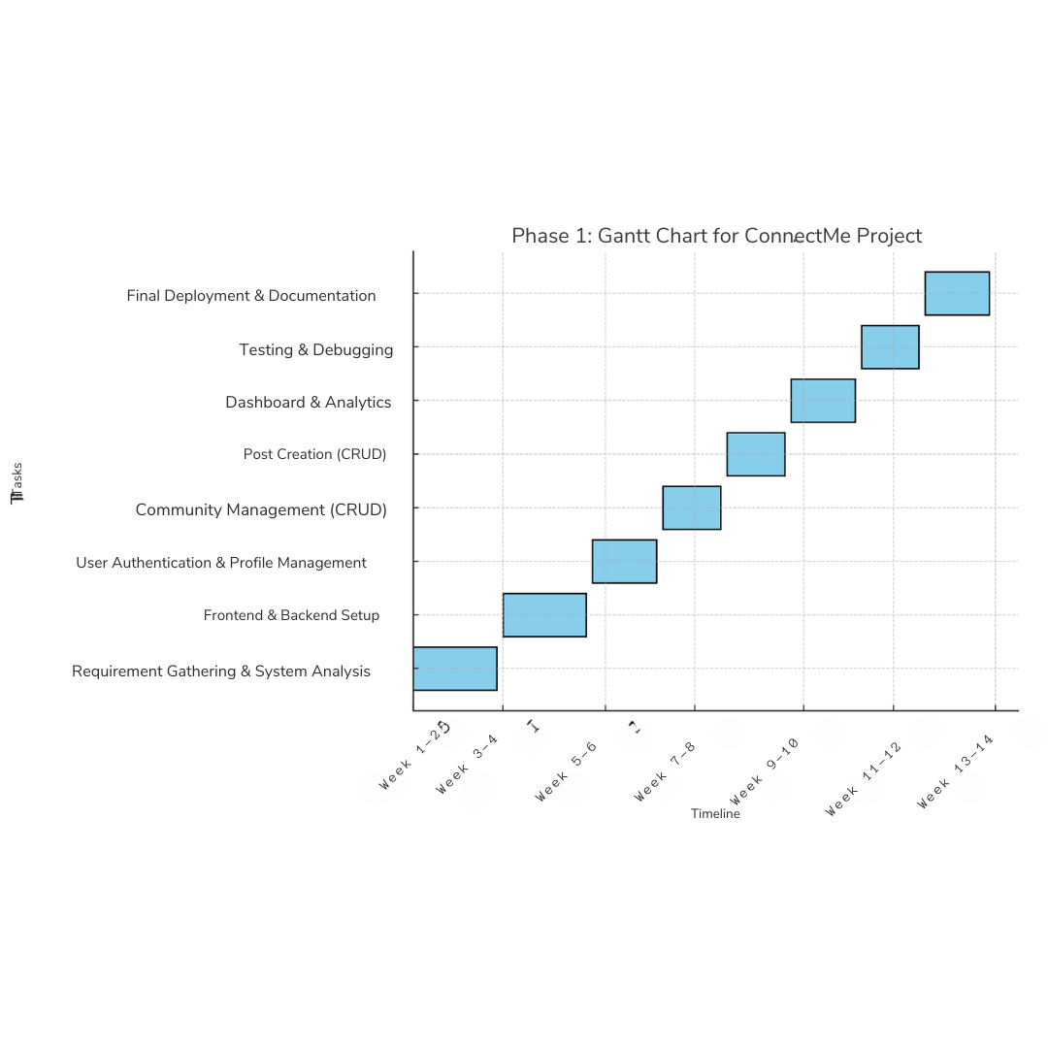

# Chapter 4 Conclusion

The first phase of the ConnectMe project lays a strong foundation for a niche social media platform that focuses on user engagement through shared interests. By implementing essential features like user authentication, community management, and CRUD operations, ConnectMe will create an environment where users can connect meaningfully with others who share their passions.

## 4.1 Expected Outcome

i) A functional social media platform with secure authentication and robust CRUD operations.

ii) A user-friendly interface allowing easy creation and management of communities.

iii) A responsive and scalable platform ready for future enhancements.

# References

Relevant academic papers, articles, and online resources on social media platforms, user engagement, and niche communities.

# 